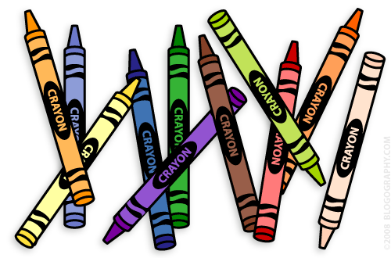**Our 1st Grade Classroom News**

**The Week of August 29th – September 2nd**

**Email:** [**Lweeks@bluevalleyk12.org**](mailto:Lweeks@bluevalleyk12.org)

**Website:** [**www.bluevalleyk12.org/hes/lweeks**](http://www.bluevalleyk12.org/hes/lweeks)

**Important Info**

Aug. 30th Early Release Day

Aug. 31st Picture Day (AM)

Sept. 1st Reading Logs Start

Sept. 5th No School

Sept. 9th Field Trip Permission Forms Due

* Reminder to sign up for a parent/teacher conference using the link below (use your child’s first and last name to sign up if possible)  
  <https://www.volunteersignup.org/3FEPD>
* Library checkout will be on Thursday this week due to a scheduling conflict.
* Field trip permission forms were sent home last week.

**Upcoming Events**

**Challenges of the Week**

**Math Challenge of the Week:**Have your child come up with story problems that includes 2 things joining together. For example: I have 8 lollipops. Then my friend gave me 4 more. How many lollipops do I have now?*You can make this as hard (higher numbers) or easy (lower numbers) as you think your child can handle. You could also have them use more than 2 numbers.*  
  
**Reading Challenge of the Week:**During reading groups, we are talking about 5 strategies to use when they get stuck on a word. ***1.****Put your finger under the word.****2.****Get your mouth ready****3.****Think about what makes sense.****4.****Look at the picture.****5.****Find a chunk in the word that you know.* While reading with your child this week, see which strategy your child used when they got stuck on a word. They may have had to use more than 1 strategy on a word! Have them write about which strategy they used! *For more of a challenge, have a student find a super challenging word in the dictionary and try to pronounce it. What word did they choose? What strategy helped them?*  
**Writing Challenge of the Week:** Finding a comfortable place to write can help your child write better sometimes. Have your child find a comfortable place to write around your house. Where did they decide to write? What materials did they bring with them to their writing spot? Did it help them write better? Have your child write down where they picked to write and what things they brought with them!

**Website of the Week:** Forming Sentences is a great website for 1st graders with beginning writing skills. This will help them identify the order of words and reinforce capital letters and punctuation marks. <http://www.softschools.com/language_arts/games/sentence_structure/form_a_sentence/>

**App of the Week**: [World Book Animals](http://itunes.apple.com/us/app/world-books-world-of-animals/id441771838?mt=8)is a fantastic app for students that love learning about animals! Students can click different pictures of animals and find videos, pictures, and information about that animal. There are TONS of animals to explore and really neat information about them. This one does cost some money so I definitely would take a look at it on the app store and see if it is worth it to you to buy.

**Tech of the Week**